Thessaloniki

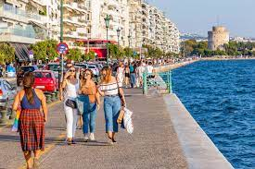

The city:
Thessaloniki is the co-capital of Greece, with over 1.000.000 inhabitants and the capital of the geographic region of Macedonia. The city is Greece's second major economic, industrial, commercial and political centre, and a major transportation hub for Greece and southeastern Europe, notably through the Port of Thessaloniki. The city is renowned for its festivals, events and vibrant cultural life in general,[12] and is considered to be Greece's cultural capital.

The city was founded in 315 BC by Cassander of Macedon, who named it after his wife Thessalonike, daughter of Philip II of Macedon and sister of Alexander the Great. An important metropolis by the Roman period, Thessaloniki was the second largest and wealthiest city of the Byzantine Empire. It was conquered by the Ottomans in 1430 and remained an important seaport and multi-ethnic metropolis during the nearly five centuries of Turkish rule. It passed from the Ottoman Empire to the Kingdom of Greece on 8 November 1912. Thessaloniki exhibits Byzantine architecture, including numerous Paleochristian and Byzantine monuments, a World Heritage Site, as well as several Roman, Ottoman and Sephardic Jewish structures. The city's main university, Aristotle University, is the largest in Greece and the Balkans.

Thessaloniki is a popular tourist destination in Greece. In 2013, National Geographic Magazine included Thessaloniki in its top tourist destinations worldwide,[16] while in 2014 Financial Times FDI magazine (Foreign Direct Investments) declared Thessaloniki as the best mid-sized European city of the future for human capital and lifestyle.

Transport:
The Nursing department of the International Hellenic University, (where the workshop will take place) is located at Alexandreio Campus, at the town of Sindos, which is 15Km away from the city center. Getting there by taxi (up to 4 people can share) is easy as it takes about 20 minutes with a cost of approximately 25 euros. Alternatively, the visitors would have to use two buses, one to get to the city’s train station and then catch bus number 52 which will take them straight to the campus.
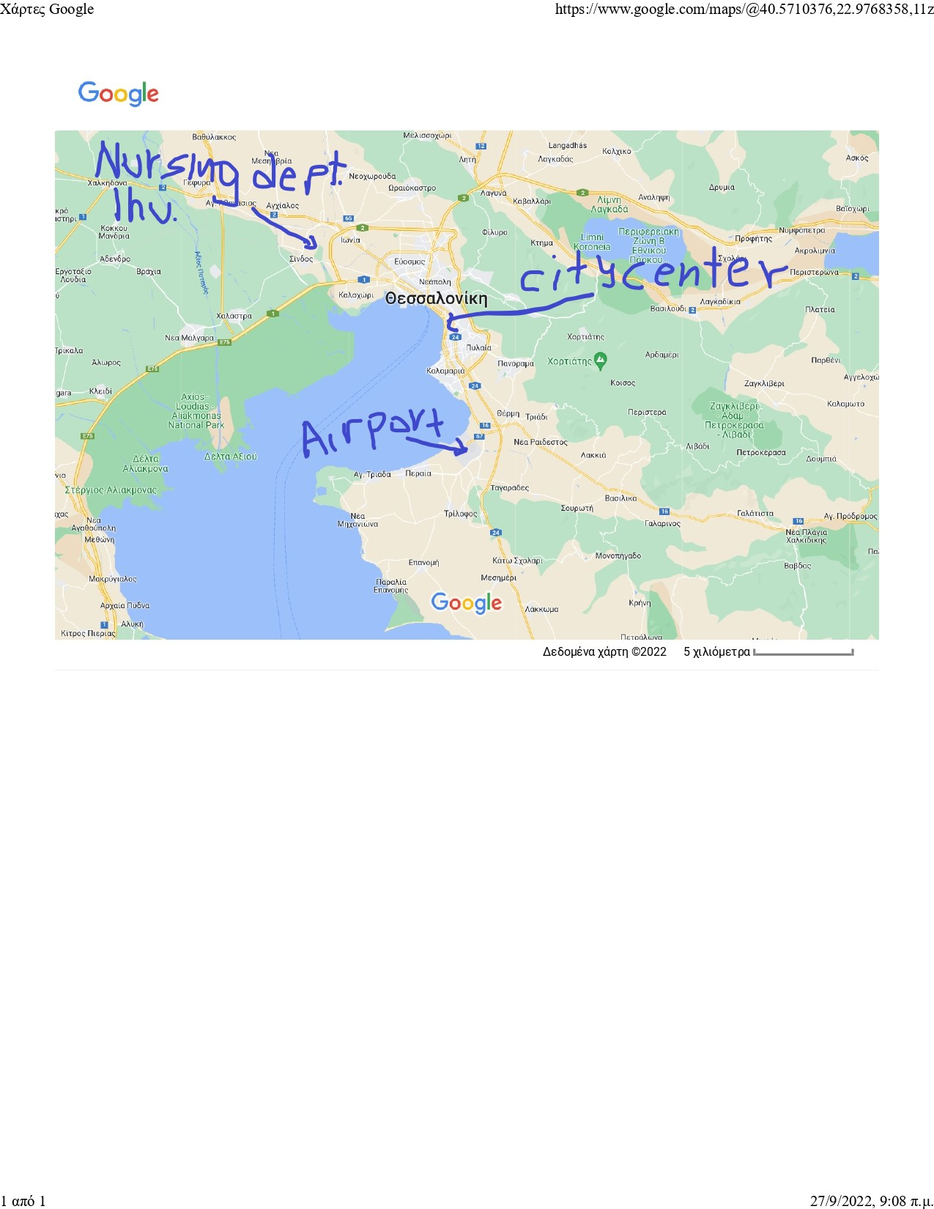
Hotel Stay:
It is preferable that our international guests choose a hotel within the boundaries of the city center as shown in the map below.
Some suggestions include but are not limited to the following:

- ABC hotel,
- Egnatia Hotel
- Egnatia Palace Hotel
- Imperial Plus Hotel, Thessaloniki
- Queen Olga Hotel




